UNIT – V – LAB PRACTICE (12hrs)

I. Phonetics a) Phonology - Pure Vowels, Diphthongs , Plosive Consonants, Fricates, Affricates, Nasal sounds, Gliding vowels, Lateral sounds, Stress, Intonation, Rhythm, Dialogue
Phonetics
Phonetics is a branch of linguistics that studies how humans produce and perceive sounds, or in the case of sign languages, the equivalent aspects of sign. Phoneticians—linguists who specialize in phonetics—study the physical properties of speech.
What is phonetics and examples?
An example of phonetics is how the letter "b" in the word "bed" is spoken - you start out with your lips together. Then, air from your lungs is forced over your vocal chords, which begin to vibrate and make noise. The air then escapes through your lips as they part suddenly, which results in a "b" sound.

Phonology
Phonology is typically defined as “the study of speech sounds of a language or languages, and the laws governing them. Phonology is defined as the study of sound patterns and their meanings, both within and across languages. An example of phonology is the study of different sounds and the way they come together to form speech and words - such as the comparison of the sounds of the two "p" sounds in "pop-up."
What is phonology and types?
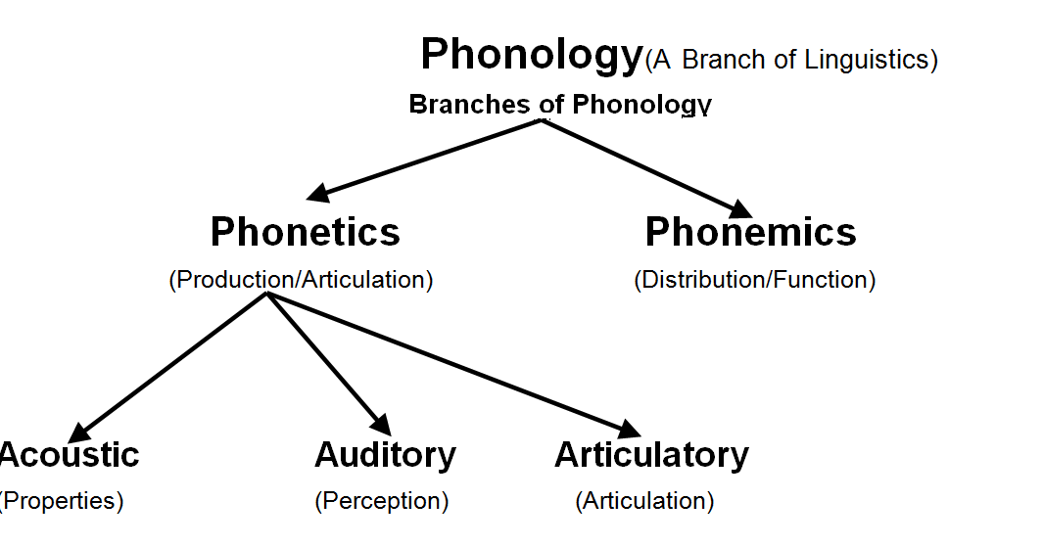

Phonetics is the study of human sounds and phonology is the classification of the sounds within the system of a particular language or languages. • Phonetics is divided into three types according to the production (articulatory), transmission (acoustic) and perception (auditive) of sounds.

Pure vowel
A pure vowel is a sound that is articulated at the beginning and end of the word. It is relatively fixed and will glide in the up and down direction. The monopthongs can be really contrasted along wth diphthongs in which the vowel quality changes. It will have the same syllables and hiatus with two vowels.
5 pure vowels
While there are thousands of vowel sounds in the world's languages there are only five important ones for singing in any language: I, E, A, O, U, which are pronounced eee, ay (as in hay), ah, oh, and oooo (as in pool).
the number of pure vowels is 12. Pure vowels are called monophthongs and impure vowels are called diphthong. Main difference between them is that diphthong glides from one sound to another but monophthongs sounds remains relatively fixed.

Diphthong
Diphthongs are vowel sounds that begin as one sound and blend into another when they are articulated. They can be achieved through the use of two consecutive vowels, as well as one vowel that changes as it is pronounced. Diphthongs are sometimes referred to as gliding vowels. This term relates to the way in which the vowel sound is articulated. With all speech sounds, including vowels and consonants, air flows through the vocal cords. Each sound requires different alteration and constriction of the vocal cords to articulate. These sounds are represented by symbols that we know of as letters.
When air flows through vocal cords, it is manipulated by the lips, teeth, tongue, and the vocal cords themselves in order to produce the desired speech sound. A vowel becomes a diphthong when it starts as one speech sound and ends as another. The term gliding vowel is a reference to the way in which the airflow glides or moves from one vowel sound articulation to another.
Having two consecutive vowels does not guarantee that a word has a diphthong. In the words “loot,” “bear,” “and “fear,” for example, only one vowel sound is articulated. Another thing to note is that diphthongs depend upon pronunciation. In some accents, a word may have a diphthong even though in another accent it does not. The New Yorker accent, for example, tends to add extra diphthongs to words like “dog” and “long,” where the single O vowel is pronounced as a diphthong similar to the word “aw.”

Diphthong Examples
There are eight diphthongs that are generally agreed upon.
- /aɪ/ Creates a speech sound similar to “eye” and usually includes the letters /i/, /igh/, and /y. Examples: my, cry, light, like
- /əʊ/ Creates a speech sound similar to “boat” and usually includes the letters /ow/, /oa/ and /o/. Examples: tow, loan, though
- /eɪ/ Creates a speech sound similar to “great” and usually includes the letters /ey/, /ay/, /ai/ and /a/. Examples: steak, pain, weight
- /aʊ/ Creates a speech sound similar to “ow!” and usually includes the letters /ou/ and /ow/. Examples: town, found, cow
- /ɪə/ Creates a speech sound similar to “ear” and usually includes the letters /ee/, /ie/ and /ea/. Examples: leer, tear, pier
- /eə/ Creates a speech sound similar to “air” and usually includes the letters /ai/, /a/, and /ea/. Examples: hair, lair, bear
- /ɔɪ/ Creates a speech sound similar to “boy” and usually includes the letters /oy/ and /oi/. Examples: oil, coy, roil
- /ʊə/ Creates a speech sound similar to “sure” and usually includes the letters /oo/, /ou/, /u/, and /ue/. Examples: cure, pure, cur

Types of Diphthongs
Linguists divide diphthongs into different categories to help classify their various sounds. The first category is the falling diphthongs, which begin with higher pitch or volumes and end with lower pitch or volumes. These are also referred to as /aɪ/ diphthongs and are often found in words that sound similar to “eye.” Examples include “like,” “fly,” “light,” and “lime.” The opposite of a falling diphthong is a rising diphthong. These begin with vowel sounds of lower pitches or volumes and end with more prominent ones. Falling diphthongs are found in the words “few,” “yell,” “weed,” “chute,” and “walk.” Similar to falling and rising, diphthongs can be classified based on whether they are closing or opening. Closing diphthongs have similar characteristics to falling, while opening is similar to rising.
Diphthongs can also be referred to as narrow or wide. Narrow ones are comprised of vowel sounds that are similar sounding and similarly pronounced. Examples include “rain” and “weight.” Wide diphthongs are vowel sounds with more drastically different articulations like in “brown,” “found,” and “now.”
PLOSIVE CONSONANTS
In the most common type of stop sound, known as a plosive, air in the lungs is briefly blocked from flowing out through the mouth and nose, and pressure builds up behind the blockage. The sounds that are generally associated with the letters p, t, k, b, d, g in English words such pat, kid, bag are examples of plosives.
What are the plosive consonants sounds?
English has six plosive consonants, p, t, k, b, d, g. /p/ and /b/ are bilabial, that is, the lips are pressed together. /t/ and /d/ are alveolar, so the tongue is pressed against the alveolar ridge. /k/ and /g/ are velar; the back of the tongue is pressed against an intermediate area between the hard and the soft ...
The plosive consonants are those consonants that are pronounced by the complete blocking of the air through the mouth. Airflow plays an important role in creating the sound. In this type of sound, the lungs are blocked to prevent the air from coming out of the mouth for a short time.
Fricatives
Fricatives are consonants produced by forcing air through a narrow channel made by placing ... which has four contrastive aspirated fricatives: /sʰ/ /ɕʰ/, /ʂʰ/, ...
There are a total of nine fricative consonants in English: /f, θ, s, ∫, v, ð, z, З, h/, and eight of them (all except for/h/) are produced by partially obstructing the airflow through the oral cavity.
Fricatives are the kinds of sounds usually associated with letters such as f, s; v, z, in which the air passes through a narrow constriction that causes the air to flow turbulently and thus create a noisy sound.
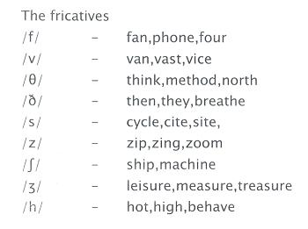
Affricate
An affricate is a complex consonant that begins in a plosive and ends as a fricative. An affricative is usually homorganic, i.e., both the plosive and fricative are made with the same articulator.
The English affricates, the 'ch sound' /ʧ/ and 'j sound' /ʤ/ are two-part consonant sounds. They begin by fully stopping the air from leaving the vocal tract (similar to a stop sound), then releasing it through a constricted opening.
What are Nasal Sounds?
- Nasal sounds in English are sounds that are released through the nose whilst air is blocked from the mouth by lowering the soft palate (velum). ...
- The nasal sounds m, n, and ng are made by blocking sounds from the mouth with the lips or tongue.
There are three nasal sounds in American English pronunciation: the 'm sound' /m/, 'n sound' /n/, and 'ng sound' /ŋ/.
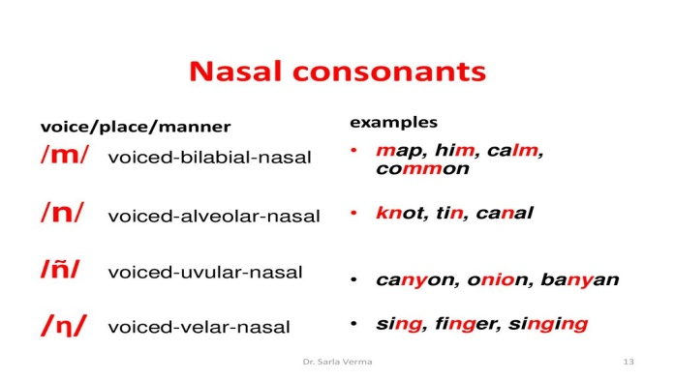
Are nasal sounds voiced?
Nearly all nasal consonants are nasal stops (or nasal continuants), where air comes out through the nose but not through the mouth, as it is blocked by the lips or tongue. Most nasals are voiced, and, in fact, the nasal sounds [n] and [m] are among the most common sounds used in languages of the world.

Gliding vowel sounds
In phonetics and phonology, a semivowel or glide is a sound that is phonetically similar to a vowel sound but functions as the syllable boundary, rather than as the nucleus of a syllable. Examples of semivowels in English are the consonants y and w, in yes and west, respectively.

How many vowels glides are there?
Glides (or "semivowels") are sounds that are not phonetically dissimilar from vowels but behave like consonants—that is, they cannot constitute the nucleus (peak) of a syllable. There are 12 pure and 8 vowel glide in English. There are five vowels in English. and there are 20 vowel sounds in English.

The lateral sound
lateral, in phonetics, a consonant sound produced by raising the tip of the tongue against the roof of the mouth so that the airstream flows past one or both sides of the tongue. The l sounds of English, Welsh, and other languages are laterals.

What is an example of a lateral sound?
A lateral is a consonant in which the airstream proceeds along the sides of the tongue, but it is blocked by the tongue from going through the middle of the mouth. An example of a lateral consonant is the English L, as in Larry.

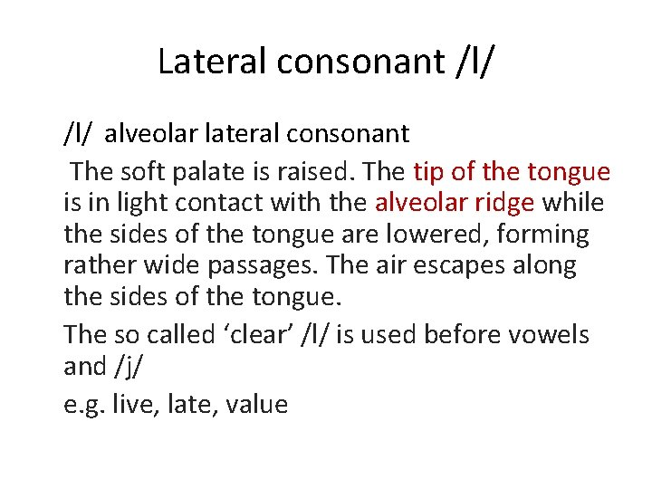
STRESS:
In linguistics, and particularly phonology, stress or accent is the relative emphasis or prominence given to a certain syllable in a word or to a certain word in a phrase or sentence.
What is stress in English sound?
Stressed vowel sounds are longer, louder, and/or higher in pitch than vowel sounds without stress. You can use just one of these features, or any combination of these features at the same time. Overall, stressed sounds are “stronger” than unstressed sounds.

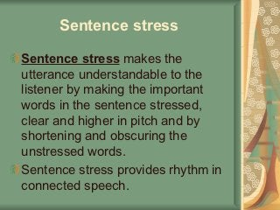
Intonation
Intonation, in phonetics, the melodic pattern of an utterance. It conveys differences of expressive meaning (e.g., surprise, anger, or delight), and it can also serve a grammatical function. Intonation is primarily a matter of variation in the pitch of the voice.
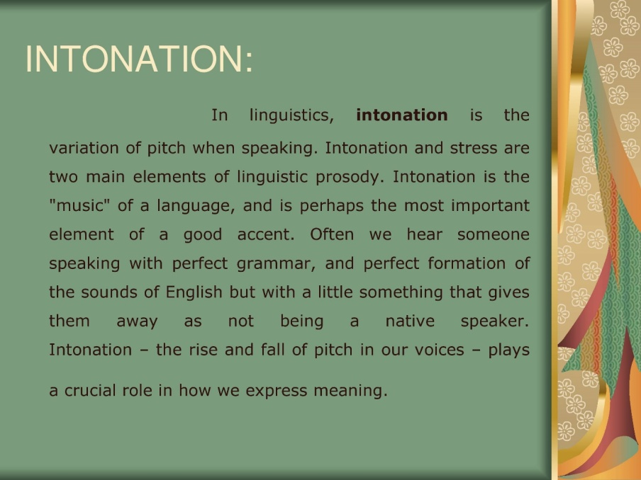
What are the 3 types of intonation?
Intonation describes how the voice rises and falls in speech. The three main patterns of intonation in English are: falling intonation, rising intonation and fall-rise intonation.

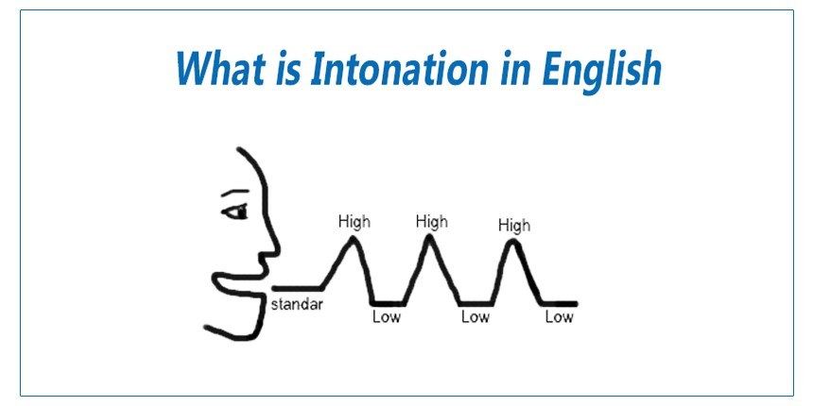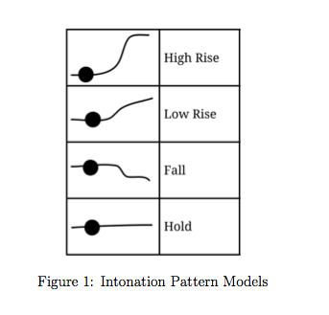

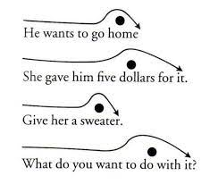
What is a rhythm in phonology?
RHYTHM
In phonetics, rhythm is the sense of movement in speech, marked by the stress, timing, and quantity of syllables. Adjective: rhythmic. In poetics, rhythm is the recurring alternation of strong and weak elements in the flow of sound and silence in sentences or lines of verse. Pronunciation: RI-them.
How is rhythm used in speech?
Rhythm can be a powerful medium to stimulate communication and social interactions, due to the strong sensorimotor coupling. For example, the mere presence of an underlying beat or pulse can result in spontaneous motor responses such as hand clapping, foot stepping, and rhythmic vocalizations.

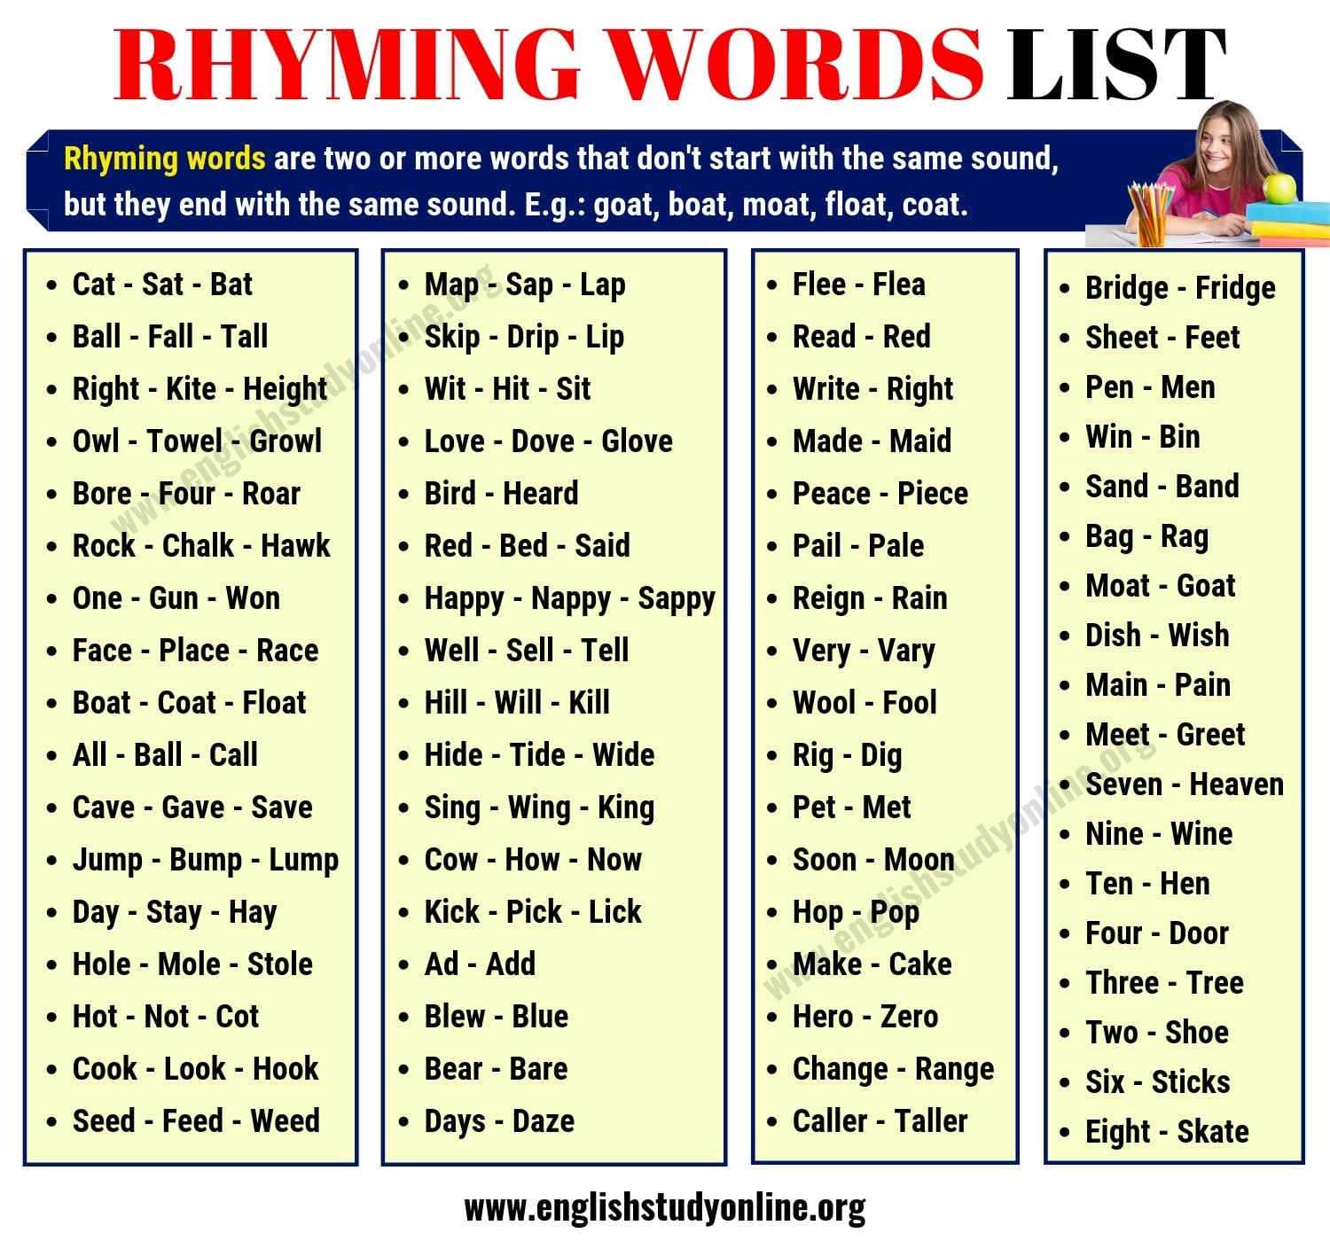

Definition of dialogue

A dialogue is a written composition in which two or more characters are represented as conversing
It is a conversation between two or more persons also : a similar exchange between a person and something else (such as a computer)
b: an exchange of ideas and opinions organized a series of dialogues on human rights
c: a discussion between representatives of parties to a conflict that is aimed at resolution a constructive dialogue between loggers and environmentalists
3: the conversational element of literary or dramatic composition very little dialogue in this filmwrites realistic dialogue
4: a musical composition for two or more parts suggestive of a conversation
